NOTE THIS AUDIT REPORT IS ONLY A SAMPLE AUDIT REPORT
SHOW CASING THE TYPE OF INFORMATION REQUIIRED IN THE AUDIT REPORTS FOR SUBMISSION IN FDPAUD5002.
It is not a full audit report. It is not complete.
You may use what ever audit report format you choose
Ensure you
- list all details ( whilst retaining confidentiality if required)
record details of what documents, sections and records you reviewed.
- use phots as applicable
Auditor: | NNNN KKK |  | Audit
Business / Facility: | 402 Pacific Highway Mount Kosciusko
Date of Audit: | DDMMYY
Time Audit Started: | 8 am | Finished |  | 11 am | Total Hrs | 3
Standards Audited against | Codex HACCP 2020  Food Standards Code (list)
Scope of audit including products audited | Receival, manufacture of cook chill of ready meals, storage and delivery.

Audit Summary:

The facility & activities are well maintained with the system being controlled and managed.
Cooking and chilling of foods are managed, with CCP records completed for each batch. The use of a cook chill tank has assisted in the automatic recording of cooking and chilling of bagged product such as gravies, custards and wet savoury meals, The recording of cook and chilled products is verified each day by the team leader. The cook tank is just over 12 months and needing annual calibration and servicing.
The HACCP manual has been updated to HACCP 2020 requirements.
The exception is the adjustment of the flow chart to reflect all inputs and outputs such as waste, packaging

Non-Conformances: list

Three non conformance to be closed out before external HACCP certification audit
1-Calibration of cook tank thermometer
2 GMP Floor waste not clean and No paper towel at handwashing sink
3 HACCP flow chart to reflect all inputs and out puts

1 observation has been raised that requires follow up action before your next audit in 1 year’s time.
-Induction and control of visitors

Present at Opening Meeting: | Auditee name Auditor name
Present at Exit Meeting: | Auditee name Auditor name

Internal Audit Form Annual :

Satisfactory (S) Unsatisfactory (U) and complete comments / corrective action column
Completed by:_NNNN Date DDMMYY

Section | S/U | Details / Notes or Corrective Action required
Management responsibility  - Is the food safety policy still current?  - Roles & Responsibilities clear/ current?  - Compliance to Regulatory requirements? | S  S  S | Pg 3 signed and displayed 30/2/22  Yes updated to HACCP 2020  S 9 Job descriptions  Regulatory requirements listed in validation table
Management Commitment  - leadership and commitment to food safety  - Food safety Culture  - training/ supervision provided?  - Are sufficient resources provided?  - Is the Food Safety System up to date and maintained with changes? | S  S  S  S  S  S | Yes S1 .3 Management commitment  Yes S 1.4 Food Safety Culture, surveys , tool box talks , training  Updated HACCP 2020 . Up to date validation table
Food Safety Program (HACCP)  - Are the members of the HACCP team still current?  - Is the scope and purpose still current?  - Have any recent changes been documented in the HACCP study?  - Is the product description current?  - Is the intended use accurate?  - Is the flow chart still correct? -  - Have all specific biological, physical and chemical ( incl allergens) hazards been identified with source of hazard for each process step in the flowchart?  - Is the HACCP Audit Table current and match Hazard Analysis?  - Are the Critical Limits for CCP’s still valid and justified? | S  S  S  S  S  N  S  S  S | NN TTT, Team leader.  DD AA HACCP member  External consultant Pg 23  Scope – see above pg 31  No changes to scope processes etc in past yr  Product description current – cook chill ready made meals pg 34  No Flow chart does not indicate waste or packaging NC 1  Flow chart steps : refer over  All specific hazards and sources listed for steps pg 35  HACCP audit table matches  CCPs are  1. Purchase– APP Supplier  2,Receival PHF Temp check < 5°C and HF  3.6. Storage Cold <5 ׄC and Frozen <-15C  4. Cooking 75 °C  5 Cooling 60°C- 21°C within 2 hours , down to <5°C further 4 hours  7. Delivery Storage Cold <5 ׄC and Frozen <-15C  Pg 56 Validation table for CCPs  1. Purchase– FSANZ 3.2.2.( 5.1)  2,Receival FSANZ 3.2.2.( 5.3 and 5.4)  3.6. Storage FSANZ 3.2.2.(6)  4. Cooking FSANZ 3.2.2.(7.1)  5 Cooling 60°C- FSANZ 3.2.2.(7.1)  7. Delivery Storage FSANZ 3.2.2.(10b)
Corrective Action |  | Incomplete  Audit report for example of audit report only
HACCP Records  - Have records been kept for all CCPs?  - Have the CCP records been verified?  - Have the verification activities been actioned, with records available?  - Do sampling and testing verify food safety controls? |  | Yes refer records  Automated cooking and cooling records for cook tank – verified on Record 7 Daily checklist  Listeria environmental swabs and Proclean verify environmental cleaning monthly.  Shelf life test sent to lab for 1 product  Green curry 8 day shelf life  29/6/202X  Green curry pouch Ready to cook  Yeast <100  Mould <100  SPC <10  Listeria Mono ND 25 g  Salmonella ND 25 H  CP Staphlococci <100  Coliforms <10  E Coli<10  B Cereus <100  satisfactory
GMP-Clean, not a source of contamination Staff facilities  - Toilets  - Hand washing  - Eating and smoking areas  - Designated handwashing sinks with soap, towel and waste bin |  | 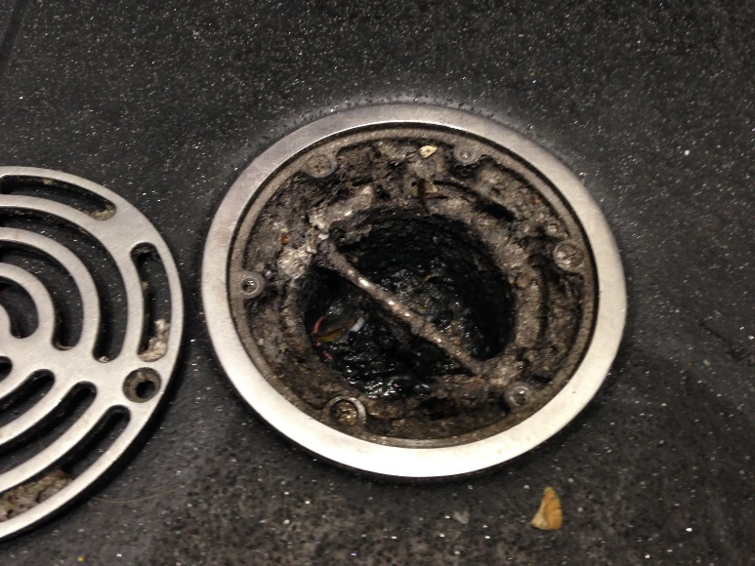  NC 2 Floor waste unclean  Auditor walk through – all staff wearing PPE  No visitor sign in log register or induction  Obs 1  No paper towel available at handwashing sink  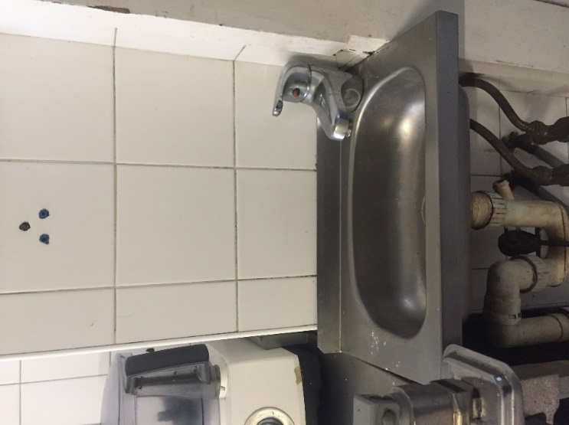
Clothing  - Personal effects storage  - Clothing cleanliness  - Hair covering worn correctly |  | Incomplete  Audit report for example of audit report only
Personal Hygiene.  - Do all staff follow personal hygiene requirements  - Etc |  | Incomplete  Audit report for example of audit report only
Premises and Environment  - Closed from outside  - Door seals intact  - Etc |  | Incomplete  Audit report for example of audit report only
Visitors  - Are visitors instructed and supervised?  - Are visitors guided in food safety procedures and health requirements?  - Do all visitors follow procedures | N | Obs 1 No visitor register at time of audit  . Carbon copy pad ran out. Before audit  Visitor policy S9.3 pg 76 to be updated to HACCP 2020 including visitor induction to production site
Supplier Approval Program |  | Incomplete  Audit report for example of audit report only
Product Identification/ labelling
- Are all products identifiable and dated?
- Are product dates correct?
- Are all materials and products traceable?
- Are production records for batches available?
Cleaning and Sanitation |  | Incomplete  Audit report for example of audit report only
Pest Control  - Are all procedures being followed?  - Regular checks for infestation?  - Treatment by qualified pest technician, Copy of licence available?  - Etc ? |  | Incomplete  Audit report for example of audit report only
Recall |  | Incomplete  Audit report for example of audit report only
Calibration
- Are procedures still correct?
- Have temperature monitoring devices been calibrated ie probes?
- Has other measuring equipment been calibrated? Ie scales, detection devices etc
Recall |  | Incomplete  Audit report for example of audit report only
Food Handling Program  - Are all procedures as documented being followed?  - Are allergen controls in place and followed?  - Are there authentic, complete records for food handling process steps? |  | Allergen list as per FSANZ 1.2.3 and schedule 9 is current and up to date.  Allergens controls in place for good received, storage. Use of standard recipes and allergen declarations on product specifications.  5 Proclean swabs done monthly to verify cleaning effectiveness that assist in allergen cross contamination  One done during audit
Corrective & Preventive Action Procedure  - Has the Corrective action recorded product evaluation and disposition/  - etc |  | Incomplete  Audit report for example of audit report only
Document and Data Control |  | Incomplete  Audit report for example of audit report only
Product Testing  - Are the product shelf life tests satisfactory and provide evidence of a safe product? |  | Shelf life test sent to lab for 1 product  Green curry  29/6/202X  Green curry pouch Ready to cook  Yeast <100  Mould <100  SPC <10  Listeria Mono ND 25 g  Salmonella ND 25 H  CP Staphlococci <100  Coliforms <10  E Coli<10  B Cereus <100  satisfactory
Notes/ Comments

Records audited :
- XXTTT Food Safety Program V1 3 issued date 17/08 22

Records: Calibration
DATE | Thermometer  (annually) | Ice slurry temp reading  [should be 0°C (+/-1°C)] | Boiling water temp reading [should be 100°C (+/-1°C)] | Corrective action / Comments | Initial
25/08/202X | Leifheit Probe | 0 | 100 | none, perfect reading | Hg

DATE | Storage  (annually) | Calibrated probe reading | Dial / gauge reading (+/-1°C) | Corrective action / Comments | Initial
25/08/202X | Freezer  Inside | -16 | -15.8 | none | hg
25/08/202X | Freezer Outside | -20 | -20.2 | none | hg
25/08/202X | Under Bench Fridge | 3 | 3.23 | none | hg
25/08/202X | Cold Room | 2.5 | 2.61 | none | hg

Cooking 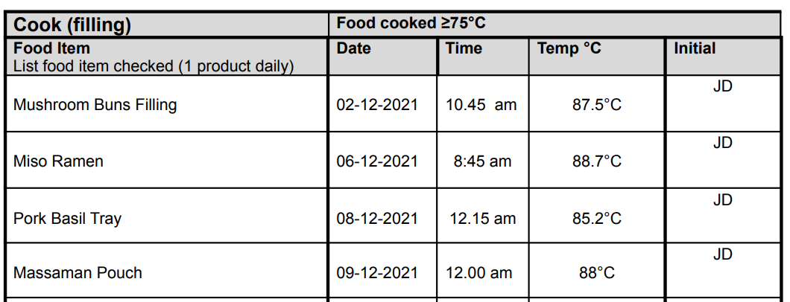
Cooling
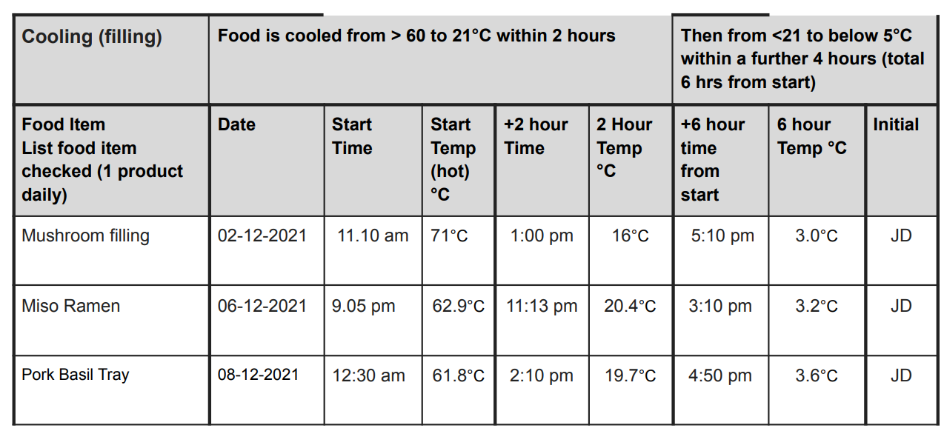
Storage Temp
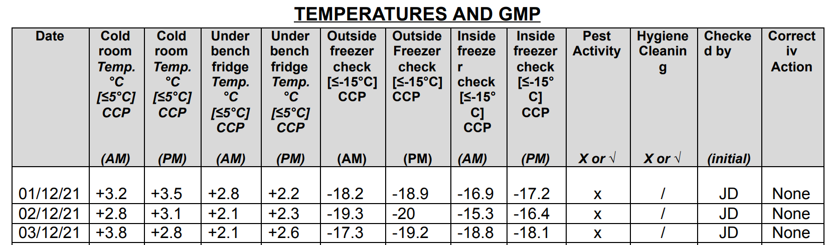
ETC Etc

Audit Non Conformances

NC. | Non Conformances | Action/ Status
 | Calibration of cook tank thermometer.  Cook tank thermometer to be calibrated annually | Open  Partial close  Closed
 | GMP Floor waste not clean and No paper towel at handwashing sink  GMP procedures to be followed as documented in manual | Open  Partial close  Closed
 | HACCP flow chart to reflect all inputs and out puts  HACCP 2020 requires all inputs and outputs to be reflected in HACCP study | Open  Partial close  Closed
Observation:  -Induction and control of visitors- Update and ensure for compliance to HACCP 2020 |  | Open  Partial close  Closed
Signed Auditor |  | Date  22/08 /2022
Signed auditee |  | Date  22/08 /2022

